**Component 2: Philosophy of Religion**

**Theme 3: Religious experience**

**Booklet 1**

|  |  |  |
| --- | --- | --- |
| **A.** | |  | | --- | |  |   **The nature of religious experience with particular reference to:**  Visions – sensory; intellectual; dreams. Conversion – individual/communal; sudden/gradual. Mysticism – transcendent; ecstatic and unitive. Prayer – types and stages of prayer according to Teresa of Avila. |
| **B.** | |  | | --- | |  |   **Mystical experience:**  PINT  **William James’ four characteristics of mystical experience**: ineffable, noetic, transient and passive.  **Rudolf Otto** – the concept of the numinous; *mysterium tremendum;* the human predisposition for religious experience. |
| **C.** | |  | | --- | |  |   **Challenges to the objectivity and authenticity of religious experience:** With reference to Caroline Franks Davis (description-related; subject-related and object-related challenges). Claims of religious experience rejected on grounds of misunderstanding; claims delusional - possibly related to substance misuse, fantastical claims contrary to everyday experiences. Challenges: individual experiences valid even if non-verifiable; claims could be genuine – integrity of individual; one-off experiences can still be valid even if never repeated. |
| |  | | --- | |  |   **Issues for analysis and evaluation will be drawn from any aspect of the content above, such as:** • The impact of religious experiences upon religious belief and practice. • Whether different types of religious experience can be accepted as equally valid in communicating religious teachings and beliefs. • The adequacy of James’ four characteristics in defining mystical experience. • The adequacy of Otto’s definition of ‘numinous’. • The extent to which the challenges to religious experience are valid. • The persuasiveness of Franks-Davis’s different challenges. | |
|  | |

**Religious Experience**

The phenomena of religious experience are different to traditional arguments for the existence of God. For the people who have these experiences, the phenomena have authority and convince them that their religious beliefs are true: sometimes even causing people to change their religious beliefs.

There are many different ways of categorising religious experiences without actually defining what it actually is**.** Put simply, we may say that **a religious experience is an encounter with the divine**.

It is a non-empirical occurrence that brings with it an awareness of something beyond us. However, the variety of religious experiences is such that it is difficult to find a common theme. Nevertheless, we may note that some of the main features of religious experiences can be set out as follows:

* God is experiencedas opposed to everyday physical objects. There is a spiritual change that clearly has a religious dimension.
* Religious experiences are often subjective as opposed to objective.
* Religious experiences are not universal i.e. not everybody experiences them as opposed to ordinary experiences e.g. a tree, the weather etc.
* Human beings often use the same conceptual scheme when they describe an ordinary experience. Thus regardless of culture we all describe a tree in the same way. However, with religious experiences, though the feelings may be similar (e.g. awe and wonder, joy, peace etc.) the object is differente.g. Jesus, Allah, Krishna etc.
* Religious experiences can be understood as pragmatic in that they bring about life changing behaviour.

There is a wide variety of religious experiences, including:

* **Visions** – used to describe experience of God or another religious figure appearing with a message.
* **Conversion Experiences** – used to describe an experience that leads to an adoption of a new religious belief that differs from a previously held belief.
* **Mystical Experiences** – used to describe experience of direct contact or oneness with God or ultimate reality.
* **Prayer** – used to describe the experience of communicating with God or a higher power through the medium of prayer.

David Hay’s book *Religious Experience Today* presents some of the findings of The Religious Experience Research Unit. These findings, which are based on a random sampling of the public include:

* 31% of British people and 35% of Americans have had an experience that they might consider religious.
* These experiences often last for a few seconds but can last much longer.
* They generally give awareness that there is more to reality than this physical world.
* They can produce a change in both behaviour and attitudes – including a sense of altruism, increased self-esteem and a feeling of purpose.

For many people throughout history the strongest demonstration of the existence of God comes from personal experience. Figures like Paul and Muhammad (pbuh) are famous examples of religious experience. However, it is not just famous people or figures from history who have religious experiences; ordinary people have experiences which have a dramatic and lasting effect on them.

**Task 1**

1. Write a definition of a religious experience using the information above.

2. How would you challenge the reality of a religious experience like receiving a vision from God?

3. How might a religious person respond to your challenge?

**Generally, we divide religious experiences into two groups: *direct* and *indirect* experiences.**

**Direct religious experiences** refer to cases where a person encounters God in a direct way. The passage below is the account of Paul on the road to Damascus where he meets the risen Jesus, who then communicates with him. This is an example of a direct religious experience because it is an event where God reveals her/himself directly to the person having the experience, in this case Paul. This experience is not willed or chosen by the person; the person experiences or observes God in some way.

Meanwhile, Saul was still breathing out murderous threats against the Lord’s disciples. He went to the high priest **2**and asked him for letters to the synagogues in Damascus, so that if he found any there who belonged to the Way, whether men or women, he might take them as prisoners to Jerusalem. **3**As he neared Damascus on his journey, suddenly a light from heaven flashed around him. **4**He fell to the ground and heard a voice say to him, “Saul, Saul, why do you persecute me?”

**5**“Who are you, Lord?” Saul asked.

“I am Jesus, whom you are persecuting,” he replied. **6**“Now get up and go into the city, and you will be told what you must do.”

**7**The men traveling with Saul stood there speechless; they heard the sound but did not see anyone. **8**Saul got up from the ground, but when he opened his eyes he could see nothing. So they led him by the hand into Damascus. **9**For three days he was blind, and did not eat or drink anything. Acts 9

**Indirect religious experiences** refer to experiences, thoughts or feelings about God that are prompted by events in daily life. For example observing a sunrise and having thoughts about the greatness of God the Creator. Acts of prayer are seen as indirect religious experiences as God is not directly revealed to a person, nor is knowledge of God revealed; instead the person learns something about God through what is observed.

**3 A The nature of religious experience with particular reference to:**

**Vision Experiences**

Religious experiences of visions and voices are unusual in that they are usually described in terms of ordinary perceptions. People who experience visions and voices describe them using phrases like ‘I saw’ or ‘I heard’. However, these sights and sounds aren’t usually heard or seen by other people. Both visions and voices occur in a variety of forms and in various faiths.

Vision experiences can happen when a person is awake or in a dream. In the vision, information may be revealed to the recipient. Visions are usually divided into three types:

1. Sensory or Corporeal
2. Intellectual
3. Dreams or Imaginative

**Sensory/Corporeal:** A vision has a sensory characteristic if it is todo with sense experience. In other words it is where external objects, sounds or figures appear before the recipient. Sensory visions can be summarised in three ways.

* Groups – Angel of Mons, during the First World War a vision of St George and a phantom bowman halted the Kaiser’s troops.
* Individual – seen by only one person, for example St Bernadette of Lourdes had several visions of the Virgin Mary. In one of these visions she was told to dig in the ground at the feet of Mary. When she did, she discovered a mountain spring. People still visit the spring at Lourdes to pray and bathe, and many report being healed in some way.
* Corporeal – an object that is external and appear to be physical in nature, but only visible to certain people, for example, St Bernadette saw Mary as a form or image like a physical person.

**Intellectual:** A vision can have an intellectual quality if the vision brings the recipient a message of inspiration, insight or instruction. It can also contain warnings! For example the Children of Fatima.

**Dreams/ Imaginative:** Some dreams can involve visions wherein the unconscious state experiences a series of images or dream narrative, which would not normally be available to the individual in conscious state.

In the Bible (Matthew 1) Joseph, while engaged to Mary, has a dream telling him not to be afraid of marrying Mary – even though she is pregnant and he is not the father. This is imaginative as it refers to a vision that occurs in dream, in which a message is received from God.

**Content of visions**

* An image or event in which there is a message – St Peter – vision of heaven
* Religious figures – St Teresa of Avila saw Jesus, Joan of Arc saw St Michael
* Places (heaven or hell) – Guru Nanak
* Fantastic creatures/figures – Ezekial – living creatures with form of a man and four wings
* Future – children of Fatima

**Task 2**

1. What are ‘visions’?
2. Write a 10 word summary of each type of vision – sensory/corporeal, intellectual and dreams/imaginative

AO2Are visions and voices genuine experiences? Some thinkers have raised the issue of how we might prove an experience is from God. Some schizophrenics, for example, hear voices telling them to kill people – which they believe are messages from God. These experiences are also linked to physical factors like fasting.

**Sensory example - St Bernadette (1844–79)**

Bernadette Soubirous was born into poverty in Lourdes, southwest France, on 7 January 1844.

On a February day in 1858, Bernadette was sent to the local river with her sister and a neighbour’s daughter to gather firewood. This landscape of great rock formations includes arches and grottos. When the three girls reached one grotto, the two younger ones took off their wooden shoes to wade across the millstream that joined the river. Bernadette stayed behind. As she stood alone beside the river she heard to her alarm a sudden rush of wind, and saw a golden cloud float out from the grotto. In the midst of the cloud stood a beautiful young woman, who seemed to float to a niche in the rock. The woman wore a white robe, blue girdle and white veil, and golden roses adorned her bare feet. Her eyes were blue and gentle, and when she smiled and beckoned to Bernadette, the girl’s fear vanished.

Bernadette drew closer, fell to her knees and began to say the rosary. The woman in the vision also had a rosary. Bernadette later said, ‘*The Lady let me pray alone; she passed the beads of the rosary between her fingers, but said nothing; only at the end of each decade did she say the Gloria with me.*’ When they had finished saying the rosary, the Lady vanished. This experience affected Bernadette so powerfully that when the other girls turned back to look for her, she was still kneeling, with a rapt look on her face. Bernadette told the others what had happened, and soon the news began to spread through the village.

When Bernadette told her priest of the vision, he made light of it, thinking the girl had suffered from a hallucination. On the following Sunday, Bernadette returned to the grotto accompanied by friends. She knelt before the grotto and the vision reappeared. Although the others saw nothing they began to tell what they had ‘seen’, and more and more local people began hearing reports of what had happened.

Bernadette had a third vision on Thursday 18 February. The same figure appeared, smiled warmly and asked Bernadette to come every day for 15 days. The next day her mother and aunt went with her, and on each subsequent visit crowds of people gathered nearby, hoping to see or hear something miraculous. Others were sceptical, and the local police questioned Bernadette many times, trying to make her admit that it was all a hoax, but she remained firm in her insistence that her visions were genuine.

On Sunday 21 February Bernadette was accompanied by many doubters, and on this occasion, Bernadette reported later, the apparition said to her: ‘*You will pray to God for sinners*.’ On 26 February, while still in the trance-like state brought on by her vision, Bernadette crawled into the grotto and, at the Lady’s direction, uncovered with her bare hands a trickle of water from which she drank and with which she washed her face. The water continued to well up and by the next day was flowing steadily down to the river. It continues to do so to this day; its discovery is regarded as a miracle.

On 2 March, the apparition bade Bernadette to tell the priests that ‘a chapel should be built and a procession formed’. The priests, still doubtful, told Bernadette to ask the Lady her name. On 25 March, when the vision next appeared to her, Bernadette asked, ‘Would you kindly tell me who you are?’ The Lady replied: ‘I am the **Immaculate Conception**. I want a chapel here.’ This answer identified the Lady as the Virgin Mary; only four years before, the dogma of the Immaculate Conception had been introduced into the Catholic Church. The term Immaculate Conception was a term for the Virgin Mary that Bernadette would not have known.

Lourdes was soon established as a place of pilgrimage. Any claims of a cure as a result of visiting Lourdes must be immediate and permanent to be regarded as a miracle. A patient’s medical records prior to the trip and their subsequent medical history are studied before a cure is accepted as a miracle. Despite the fact that only about 70 such cures have been recognised as miracles, thousands visit Lourdes each year to be washed in the waters of the spring, to share in the processions, the singing, the prayers and the impressive rites, and to breathe the pure air of faith. Many who visit Lourdes are simply searching for a renewal of faith. Whether or not the visions of Bernadette were genuine, they are still a potent inspiration.

Task 3

1. Write a 50 word summary of Bernadette’s experience.
2. What evidence supports Bernadette’s visions as a genuine religious experience?
3. If they were not genuine religious experiences, what other explanations could be given for Bernadette’s visions?

**Conversion Experiences**

Conversion experiences raise interesting issues; although the inner experience cannot be empirically detectable, the resulting changes in behaviour are something that can be empirically observed. Often these changes occur dramatically over days and weeks, which for many believers is a powerful piece of evidence for the existence of God.

Conversion – ‘change direction’ or ‘to turn around’

Conversion is also not limited to individual experience.

Communal conversion experiences can occur, in which a group of people experience a change in behaviour or beliefs at the same time. For example, the communal conversion in Acts of the Apostles chapter 2. The disciples were gathered in a room and received the Holy Spirit. ‘When the day of Pentecost came, they were all together in one place. Suddenly a sound like the blowing of a violent wind came from Heaven and filled the whole house where they were sitting. They saw what seemed to be tongues of fire that separated and came to rest on each of them. All of them were filled with the Holy Spirit and began to speak in other tongues as the Spirit enabled them.’ (Acts

Conversion may be from one major religion to another — Christianity to Buddhism, or from within one religious tradition — for example, Anglicanism to Catholicism, or from no religious tradition to a religious tradition, or from faith (believing) to faith (trusting). One example is Paul’s conversion, when he saw blinding light and heard the voice of Jesus calling him to ministry. His life was changed forever.

C.S.Lewis’ conversion is an example of an intellectual conversion. He recounts how in 1931 he walked and talked for hours with the author J.R.R. Tolkien about myth and Christianity and became convinced that Jesus was the Son of God. Augustine is an example of a moral conversion, in that his wayward life was challenged when he read the words from Romans, which exhorts the reader to abandon the works of the flesh and be clothed with Christ.

There are two types of mental occurrence that lead to a difference in conversion processes:

1. Conscious and voluntary experience, called ‘volitional type’ (gradual conversion)
2. Involuntary and unconscious experience called ‘self-surrender type’ (sudden conversion)

*GRADUAL* means the conversion takes place over a length of time, possibly even years.

*SUDDEN* means the conversion takes place suddenly, when a clear decision is made and a particular date can be given for the event.

**Task 4**

1. Write a definition of conversion religious experiences
2. Write a summary and example of:

Gradual

Sudden

Individual conversion experiences – see the information below

Communal conversion experiences

**Individual Conversion – St Paul**

The person many today know as St. Paul was not always known as such. In fact, quite the opposite is the case. The following information briefly presents the person of St. Paul before, during, and after his conversion and attempts to decipher what or who could bring such a massive change in the life of one individual. The above verses only act as personal evidence from the mouth of Paul himself as well as those of his days to the life he lived and the change that came.

One first encounters him as Saul. Born to a wealthy Jewish family of the tribe of Benjamin in the city of Tarsus in Cilicia (presently Asia Minor), he was thus a citizen of the Roman Empire by birth. He later went to Jerusalem to study law under the Pharisees and became a zealous follower. Under their teachings and politics, Saul was a witness and support of the peoples’ stoning the apostle Stephen. Stephen spoke out against the blindness of the Jewish people making specific reference to the Pharisees saying that they only followed the law superficially. Saul may have viewed this as a threat to his affinity for the Jewish religious customs, his pride concerning religious law, and his adherence to it. For similar reasons, Saul fiercely disliked Stephen along with others who were followers of a man named Jesus Christ. His animosity toward the followers of “the Way” motivated him to set out on a campaign to oppress, imprison, and eradicate these “Christians”. Already having established a fierce reputation around Jerusalem, his campaign (with the support of the high priest in Jerusalem) led him to Damascus. Some sixty miles north, the leaders of the Synagogues agreed to aid him in routing and imprisoning the Christians in that area. Who would have ever guessed what came next.....

Saul set off for Damascus with a group of travellers. When approaching the city, there was a flash and Saul was knocked to the earth. Christ appeared before him asking, “Saul, Saul, why do you persecute me?” Baffled, Saul asked, “Who are you sir?” “I am Jesus, whom you are persecuting. Get up and enter the city and you will be told what to do.” Though Saul’s companions heard a voice speaking, they did not see anything. Now, Saul was blind. His companions took him to an inn where he ate nothing nor drank for three days.

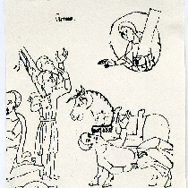A disciple living in Damascus, named Ananias, had a vision in which God told him to go to Saul, lay his hands on him, and heal his blindness. Fearing Saul’s reputation, Ananias initially hesitated only finally going from the reassurance he received from God. Ananias found Saul and did as the Lord told him. Something like scales fell from his eyes and his sight was now restored. Saul was baptized “Paul” and then spent several days with the Christians of Damascus. He learned what he could from Ananias while regaining his strength.

After spending time in Damascus preaching and spreading the Word, plots to assassinate Paul surfaced. With the help of new friends, Paul escaped back to Jerusalem. There he attempted to join with the Christian disciples. However, their fear of him and his reputation for formerly persecuting followers of the Way kept them from accepting him as one of them. With the aid of another man, Barnabas, he managed to convince them that his conversion was real. After he preached a bit in Jerusalem, more plots to kill him surfaced. So, this time his escape led him to Antioch. Briefly summarized, life for Paul after this included several missionary trips into Greece and Asia Minor with Barnabas as well as the establishment of Christian churches throughout Greece, Macedonia, Asia Minor, and even into Rome.

Thus, we conclude that Paul’s conversion and therefore changed life sprang from his own personal encounter with Jesus the Christ. This Jesus has affected the lives of many others in much the same way – both those of His day and those of the present. Again the evidence lies in the words of Paul himself as seen above.

**Task 5**

1. Summarise St Paul’s experience in 10 words
2. What did St Paul do after his experience?
3. Why might some people believe St Paul’s experience is convincing?

**Communal conversion - The Toronto Blessing**

The Toronto Blessing is an example of a corporate shared conversion religious experience. On 10 January 1994 a bizarre phenomenon is reported to have occurred at the Toronto Airport Vineyard Church. The phenomenon, which has since been called the ‘Toronto Blessing’, is said to have been an ‘outpouring of the Holy Spirit’. Although individual testimonies of the experience differ, the descriptions of its effects by witnesses are strikingly similar.

The ‘blessing’ occurred during a sermon by Pastor Randy Clark. Another senior Pastor, John Arnott, described what he saw:

When Randy Clark preached at the Airport Vineyard, the pastor claimed that ‘almost 80 per cent of the people were on the floor … It was like an explosion. We saw people literally being knocked off their feet by the Spirit of God … Others shook and jerked. Some danced, some laughed. Some lay on the floor as if dead for hours. People cried and shouted.

*The Father's Blessing* by John Arnott, pp71–2

The first time that this kind of experience is said to have occurred was in 1979. The recipient was South African minister Rodney Howard-Browne, considered to be the ‘father’ of what is sometimes called ‘Holy laughter’. Apparently, it was during a sermon in which the minister asked God to ‘touch me’ or he would ‘come up there and touch you’!

The general effects of this particular type of experience are:

* falling in the Holy Spirit – where people fall to the ground, as they can no longer remain standing in the ‘presence of God’. Some refer to being stuck to the floor by ‘Holy Ghost Glue’.
* shaking – part of or the whole of the body shakes ‘under the power of God’.
* weeping – this is said to be the result of repentance for one’s sins or feeling the burden of souls not yet saved.
* laughter – this ‘Holy laughter’ is said to occur when the Holy Spirit comes into a person’s life. Those who believe this to be a genuine form of religious experience say that laughter is an expression of the joy experienced. It is, perhaps unsurprisingly, the most controversial element of the experience.

The interesting thing about the ‘Toronto Blessing’ is that it was a corporate experience – that is, it appears to have been undergone by many people at the same time. Since January 1994, this type of shared religious experience is said to have occurred to many Christians all around the world.

The influence of the Toronto Blessing

The events of the first blessing have led to a development of the worldwide Faith Movement. The movement believes that humans have supernatural power or ability within them. By expressing one’s faith in God an individual is able to produce what is called ‘a divine force’ that has healing powers and can produce wealth and success. It is through genuine faith and speaking to God that God will respond and accomplish what we ask for and desire.

Attendance at the Toronto Airport Christian Fellowship in the 1990s numbered thousands for an evening service, and **many people experienced a conversion to Christianity or a renewal of their faith.** The effects of the Toronto Blessing were international in scope and it was estimated to have influenced 4,000 churches in England, particularly the Pentecostal and Charismatic Movements. The influence has lessened in recent years but still has an underlying influence on aspects of the Charismatic Movement.

Was the Toronto Blessing a genuine religious experience?

For those who have had the experience, the strengthening of their faith would appear to be strong evidence of a genuine religious experience, as is the fact that so many people had the experience or witnessed the events. The worldwide influences of the renewal movement would be further support that the experiences came from God.

However, many would argue that the experience was not genuine but the result of mass hysteria: an example of the phenomenon known as Mass Psychogenic Illness. Those who reject the claim that the religious experiences were genuine argue that the people’s desire to experience God was strong and the environment in which they were listening to the sermon was right for such hysteria to develop. Others would argue that the fact that the experience was life-changing for so many and led to a renewal of the Christian faith that spread worldwide proves that the experiences were genuine. Such revivals occur within religions from time to time and many people think that there is no reason to doubt that the blessing is from God.

Task 6

1. Using the internet and the material above, write an account of the events of the Toronto Blessing, including reference to the influence of the experience on individuals.
2. Read the account of the first Day of Pentecost in Acts 2:1–21 (New Testament). In what ways are the experiences of the apostles similar to those who have experienced the Toronto Blessing?

**Mystical Experiences**Mystical experience refer to a variety of religious experience in which the subject is transformed and reports the loss of individuality, the oneness of all reality, union with the deity and the unity of the subject of the experience with the object of the experience. Mystical experiences involve special mental states or events that allow an understanding of ultimate truths.

Mystical experiences have several common features that have been identified by scholars such as Walter Stace:

Mysticism: a religious experience where union with God or the absolute reality is sought or experienced.

• A sense of union with the divine.

• A sense of dependence on God.

• A sense of separateness from God.

• Time is transcended.

• ‘Noetic’ experiences (William James) or a ‘showing’ (Mother Julian of Norwich) – something is clearly revealed to the person receiving the experience.

• A sense of joy and well-being.Paul Tillich described two stages in a mystical experience: The first is an event or encounter. The second is a special understanding of that event as the result of ecstasy, a special way of looking at the event which reveals its religious significance.

There are mystic traditions in all major world religions; Sufism in Islam, Kaballah in Judaism and the writing of Ramakrishna in Hinduism. Often, people will invoke mystical experiences through various methods; meditation, pilgrimage, fasting, hypnotic movement and sensory restriction or over-stimulation.

**Ed Miller**

Miller regards mystical experiences as ‘the pursuit of a transcendent, unitive experience with the absolute reality’ and created the following summary:

1. Transcendent: not localisable in space and time, lies beyond the everyday realm of physical senses.
2. Ineffable: not expressible in language, can’t be described
3. Noetic: conveying illumination, truth. Knowledge is gained through the mystical experience that would otherwise not be available to the recipient through ordinary means.
4. Ecstatic: filling the soul with bliss, peace, overwhelming
5. Unitive: uniting the soul with reality. The feeling of complete oneness with the divine

**Task 7. Use the old AS textbooks to research Rumi’s mystical experience. Why can it be seen as transcendent**

**Example of mystical experience - St Teresa of Avila (1515–82)**

Teresa’s father was strict and brought up his family never to lie. Her mother loved to read romantic stories of which her husband did not approve so she hid them from him, telling Teresa not to tell her father. Teresa therefore had conflict from an early age between a father who despised lying and a mother who wanted her daughter to lie for her. The effect on Teresa was that, as she later said, she was always afraid that no matter what she did she was going to do wrong, and grew up convinced that she was a sinner.

There is no evidence that she was a pious teenager, and her interests were flirting with boys, clothes and rebelling. By 16, her father decided that she was out of control and sent her to a convent. Because of the belief that she was a sinner, Teresa decided to become a nun, because she was bound to go to hell. Her father was opposed. Teresa reported that he said, ‘When I am dead you might do as you please.’ One night she ran away to the Carmelite Convent of the Incarnation in Avila.

Life in the Carmelite convent was not harsh, and the nuns could travel when and wherever they wished. The wealthier nuns kept servants and lapdogs, wore jewellery, colourful sashes and perfume, and lived in private suites, while their poorer sisters slept in a dormitory. There was a parlour where they could meet friends and relatives, and the nuns could have *devotos*, men who would visit them regularly (in theory) for spiritual guidance.

After a year in the convent, Teresa’s health began to fail; she suffered fevers and fainting spells and was believed to have tuberculosis. She left the convent and stayed briefly with an uncle who introduced her to mental prayer through Francisco de Osuna’s *Third Spiritual Alphabet*. The prayer of quiet was just what Teresa needed as she suffered what she described as ‘noise in the head’. As she grew worse, her father brought her home to die. She fell into a deep coma and soon it was thought that she was dead. Her grave was dug, and she would have been buried if her father had not insisted she was not yet dead. Several days later she awoke from her coma, although she was unable to open her eyes because they had been sealed shut with wax in preparation for her burial. Teresa described her own state on waking:

*My tongue was bitten to pieces; nothing had passed my lips: and because of this and of my great weakness my throat was choking me so that I could not even take water. All my bones seemed to be out of joint and there was a terrible confusion in my head. As a result of the torments I had suffered during these days, I was all doubled up, like a ball, and no more able to move arm, foot, hand or head than if I had been dead, unless others moved them for me. I could move, I think, only one finger of my right hand.*

http://www.catholic.org/clife/mary/app.php?id=1

She went back to the convent and when she was almost 40 she began to have a series of remarkable visions, which she said were ‘seen not with the eyes of the body, but the eyes of the soul’:

*One day, when I was at prayer, the Lord was pleased to reveal to me nothing but His hands, the beauty of which was so great as to be indescribable ... A few days later I also saw that Divine face, which seemed to leave me completely absorbed. And finally, there stood before me the most sacred humanity in the full beauty and majesty of His resurrected body ... The visions were lit by an unearthly light: It is a light so different from what we know here below that the sun's brightness seems dim by comparison ... It is like looking upon very clear water running over a bed of crystal and reflecting the sun, compared with a very muddy stream running over the earth beneath a cloudy sky. It seems rather to be natural light, whereas the other is artificial.*

http://www.cs.drexel.edu/~gbrandal/Illum_html/Teresa.html

In the passage below, Teresa describes her most famous vision:

*I would see beside me, on my left hand, an angel in bodily form ... He was not tall, but short, and very beautiful, his face so aflame that he appeared to be one of the highest types of angel who seemed to be all afire ... In his hands I saw a long golden spear and at the end of the iron tip (I seemed to see) a point of fire. With this he seemed to pierce my heart several times so that it penetrated to my entrails. When he drew it out, I thought he was drawing them out with it and he left me completely afire with a great love for God. The pain was so sharp, that it made me utter several moans; and so excessive was the sweetness caused by the intense pain that one can never wish to lose it, nor will one's soul be content with anything less than God.*

Lavin, *Bernini and the Unity of the Visual Arts* (p107), 1981

Although her visions are the most famous part of her religious experiences, she considered them inferior to the quiet sense of union with God that she achieved later in life. She tried to hide her visions from the other sisters as she found them disorienting and embarrassing. Also, at this time visions were dangerous, and it was not unusual for visionaries to be burnt at the stake as heretics. Teresa felt drawn to a more strict life of poverty and self-denial, including fasting.

In 1562, she began a reform of the Carmelite order at a small convent in Avila. Here, she wrote a treatise, *The Way of Perfection*, as a guide to convent life. In spite of her desire for poverty, silence and solitude, Teresa spent the last years of her life travelling all over Spain, becoming a celebrity and wielding power over her fledgling reform. She began a reformed Carmelite order for men, beginning with a small foundation for two hermits, one of them the famous mystical poet John of the Cross, whom she would later appoint ‘John of the Cross confessor to the nuns of the Incarnation’.

In 1571, Teresa returned to the convent at Avila as prioress. She was an effective prioress, straightening out the convent’s finances, so the nuns once again had enough to eat, and tightening up their lax practices.

Teresa died in 1582 and was canonised by Gregory XV in 1622. In 1969 she was proclaimed a Doctor of the Church for her writings.

**Task 8**

1. Write a brief summary of St Teresa’s experience.
2. Why is it seen as an ecstatic mystical experience? Do you think it shows any other aspects on Miller’s list?

**Prayer Experiences**

Prayer is the experience of communicating with God; in some ways, all religious experiences can be seen as a form of prayer. Prayer can be categorized in several different ways, as different forms of prayer can be identified.

**Teresa’s types of prayer**

St. Teresa of Avila (1515-1582) was a Spanish mystic and Roman Catholic saint. She had several religious experiences during her life, and wrote about the importance of mystic prayer to religious life. Teresa believed that the purpose of life was union with God, which is also the purpose of prayer. Therefore, the purpose of life is union with God through prayer. She wrote of the seven types of prayer in her work, *The Interior Castle*, and the stages of prayer in the analogy of the garden.

**The Garden Analogy**

The analogy is presented in the Autobiography of Teresa of Avila, and gives the metaphor of a garden; with the earth representing the soul and water being the understanding of grace. Teresa stated that *“a beginner must look on himself as one setting out to make a garden for His Lord’s pleasure, on most unfruitful soil which abounds in weeds. His Majesty roots up the weeds and will put in good plants instead.”*

**Task 9** - Read through the following explanation of the four stages of prayer. Make notes on the stages under the following headings:

1. First Water (mental prayer)



1. Drawing Water (prayer of quiet)



1. Irrigated Garden (imperfect union)



1. Rain (perfect union)



The first stage consists of drawing, or attempting to draw, water from a well by one's own effort. She calls this “the First Water” or “mental prayer”. In it, we withdraw our minds from the outside world, and focus our minds upon seeking penitence and meditating upon Jesus' sacrifice on the cross. This is a slow and painful stage, in which we are filled 'drop by drop'. There is considerable strain involved. But through these efforts we can draw up some of our inward understanding of Grace. She says, “We shall do alright if we walk in righteousness and cling to virtue, but we shall advance at a snail's pace. Freedom of spirit is not to be had in that way.” God has placed the water in the well of our garden. At other times, the well is dry and we must await more water. It is not helpful or healthy to grasp at the water that isn't there. We must wait for the well to again fill up before we can again draw water. God sometimes suspends our understanding. We must accept this. We must wait and prepare our garden for the life sustaining water. This stage, or beginning method is useful at first, and all men will have to fall back on it in their prayer life, but it is the lowest stage and least effective.

Still maintaining the metaphor of a garden, she describes the second stage as drawing water by means of a “windlass” (which evidently is a kind of pulley). In this way we are aided, by God, in our drawing of understanding. This is the “prayer of quiet”. Much less labour is now required, “the soul becomes recollected”, and one begins “to come in contact with the supernatural. One still strains but the burden is much less. We are starting to be won over by the divine and we have a greater and more frequent understanding of things. “On arriving at this state, the soul begins to lose desire for earthly things.” We begin to become detached. There are fewer and fewer distractions. We are given over to a state of quietude. After our justification, we begin our process of sanctification. We are given over to Christ and are transformed, through Him, into more perfect people. In this stage, we are interiorly made aware of our transformation.

The third stage is described as a garden which has been irrigated. We no longer must continually strain but leave our soul open to understanding. The Lord takes over our work and becomes a gardener Himself. We are essentially enraptured and in a state of perfect joy. The garden is beginning to flower. “The soul's humility is now greater and more profound than it was before. It clearly sees that it has done nothing except consent to the Lord's granting it graces, and embraces it with its will.” St. Teresa admits that a perfect union with God is possible in this lifetime, at least temporarily. This stage is almost a complete union, except that one is conscious of this rapture.

The fourth stage is this union. She likens it to rain falling upon the garden. We make no effort, no strain. We are completely enraptured. This rapture is a result of a perfect, though, temporary union with God. It is a special grace. She compares the union with God to a blazing fire and the state of one's soul to slug of iron. In this fire the iron slug will change its nature and glow. This is the soul enraptured. Both Martin Luther and Thomas a Kempis use similar analogies to describe the union of man and God. In this state we can no longer consciously analyse our experience. In this way it differs from the third stage, though it is contingent on that earlier stage. Such a stage is brief. St. Teresa herself says he has only experienced it for periods of less than half an hour. In this stage, time, memory and imagination melt away, leaving one only in the presence of God. It is as if one has been lifted into heaven.

**The Interior Castle**

This work describes the ‘seven mansions’ or ‘seven dwelling places’ that each represent a step towards unity with God. It is a guide for spiritual development through service and prayer. Initially, we are introduced to those outside the castle who are described as paralyzed and crippled by sin. This level represents those who are spiritually and morally bound by evil.

**The seven mansions are as such:**

**Fill in the missing words – Jesus, mansion, marriage, God, castle, earthly,**

|  |  |
| --- | --- |
| **Mansion 1** | The souls are surrounded by sin and are only just starting to seek God’s grace through humility, in order to achieve perfect. The souls are still distracted by their earthly endeavours. |
| **Mansion 2** | The mansion of the practice of prayer. The souls seek to advance through the ________ by daily thoughts of God, humble recognition of God’s work in the soul and ultimately, daily prayer. |
| **Mansion 3** | The mansion of exemplary life. In this mansion the souls have a love for ____ that is so great that they have an aversion to both mortal and venial sin, and a desire to do works of charity for the ultimate glory of God. |
| **Mansion 4** | The prayer of quiet. During this time _____ comes to the person in their imagination where a relationship of personal love grows towards great depths of intimacy. The person becomes inwardly quiet and peaceful, absorbed in love, love within and without. Nothing else is important. |
| **Mansion 5** | In this ________, the soul begins to prepare itself to receive gifts from God, and becomes aware of the unity with God. Teresa says it is like God becomes the cocoon in which the person dies. It is a period of darkness, but yet the soul is certain beyond doubt that it is with and in the Lord. |
| **Mansion 6** | The mansion of spiritual betrothal. The person also receives special teachings and revelations that fit its inner needs. The results of these events create within the person intimate knowledge of each person of the Trinity, a deep self-awareness that is rooted in humility, a rejection of all ________ things that are not necessary to the continuance of this great love relationship, and finally a sense of joy so overwhelming they must shout it from the rooftops. |
| **Mansion 7** | The mansion of spiritual __________. When the person is ready for spiritual marriage, the Lord removes the scales from their eyes and they see and understand how beautiful they have been made by the Lord. Thus, fortified, they are united in marital love deep within the Self. They become one, and no longer fall into ecstasy. |

**Put very simply -**

**3 B Mystical experience:**

**William James’ four characteristics of mystical experience**

William James was a philosopher and psychologist, and the author of *The Varieties of Religious Experience: a study in the human nature.* In his book, James aims to survey the types of religious experience as a psychologist and to present the findings of this survey and its implications for philosophy.

James felt that religious experience was at the very heart of religion. He said that religion was *‘the feelings, acts, and experiences of individual men in their solitude, so far as they apprehend themselves to stand in relation to whatever they may consider the divine...’ (Varieties: Lecture 2).*

James noted that religious experiences have great authority for the person who has them and can often have a marked effect in a person’s life. He observed that conversion experiences are characterized by religious beliefs becoming central to a person’s life (see Saul’s Conversion). As religious experiences can so noticeably change people’s behaviour, James suggested that religious experiences were the inspiration and source of religious institutions.

Much of his book concentrates on descriptions and first-hand accounts of experiences. Sceptics viewed some of these as examples of psychological disorder, but James disagreed and placed such accounts as central to any understanding of religion.

Four characteristics were found to be particularly prominent in mystical religious experiences of God:

1. **Ineffable:** The experience is beyond proper description. The direct experience of God goes beyond human powers of description.
2. **Noetic:** Mystics receive knowledge of God that is not otherwise available. In this sense religious experiences are direct revelations from God.
3. **Transient:** The experience is a temporary one that cannot be sustained, although it may have long-lasting effects.
4. **Passive:** The experience is not initiated by the mystic but rather they feel that something is acting upon them. *(James saw this as evidence against arguments claiming that a religious experience can be explained by saying a person willed it)*

James suggested that religious experiences were ‘psychological phenomena’; a part of a person’s psychological make-up. However, he did not see this as a criticism of his argument, but explained that religious experience is natural to a person, just like other psychological experience like thinking and self-awareness. James’ conclusions rest on three key principles: **empiricism**, **pluralism** and **pragmatism**.

* Empiricism: The many case studies produced are empirical evidence of the effects of religious experience. This evidence provides us with clues as to the reality beyond what we see and hear. In response to those who might object that he is interpreting the data, James argues that we interpret all our experiences.
* Pluralism: James’ research into experiences in different faiths led him to conclude that they were similar. Those having experiences may be experiencing the same ultimate reality, but interpreting it as their religious belief structure. Therefore a Christian might interpret an experience as the Holy Spirit, whereas a Sikh may interpret it differently.
* Pragmatism: James believed that truth was not fixed and that what is true is whatever has great value to us. As a religious experience has great value to those it effects, we have to conclude that there is truth to be found in religion.

William James believed that all religious experiences indicated the probability of God (although as a pluralist he referred to ‘the spiritual’ and ‘higher aspects’ of the world and the self). He was more interested in the effects of religious experiences. To James, the validity of a religious experience rests upon the effects it produces – are lives changed? James’ argument for God is very general; the phenomena of religious experiences point to a higher order of reality.

**Task 11**

1. Apply James’ four characteristics to the account of Saul on the road to Damascus.
2. Explain how James defines religion in your own words.
3. Using the link below, read pages 252-282 of James’ Varieties of Religious Experience. You must make notes on the following topics.

Characteristics of mystical states of consciousness

Examples of mystical states of conscious

Are they authoritative?

*https://worldu.edu/library/william_james_var.pdf*

**Rudolf Otto and the numinous – the human predisposition for religious experience**

Rudolph Otto pointed out that a central element of direct experiences of God was an *‘apprehension of the wholly other’*. He described this wholly other as ***‘numinous’*** (from the Latin word numen, which refers to a supernatural divine power)– meaning the world that is beyond the physical observable universe in which we live. Therefore, Otto refers to direct experiences of God as being completely outside of our possible knowledge and experience.

Otto also noticed that people who have had religious experiences describe them using words like ‘awe’ and ‘wonder’, but the actual nature of the experience was ***ineffable*** *(experiences which it is beyond human powers and abilities to fully describe and communicate)*.

**Numinous:** Religious experiences of awe and wonder in the presence of an almighty and transcendent God. It is the awareness of human nothingness when faced with a holy and powerful being.

In his book **The Idea of the Holy**, Otto coined the term ‘numinous’ to describe the event; the individual was both attracted and repelled by a sense of awe and wonder. Simon Peter’s words to Jesus after the miraculous catch of fish express this paradox well: *‘Depart from me, for I am a sinful man, O Lord’ (Luke 5:8).*

He analysed this type of experience in terms of the Latin phrase ‘*mysterium tremendum et fascinans’*.

The tremendum component of the numinous experience comprises of three elements:

1. *Awe-fulness – inspiring awe.*
2. *Overpoweringness – inspires feelings of humility.*
3. *Energy – impression of vigour and compelling.*

The mysterium component has two elements:

1. *Wholly other – totally outside our normal experience.*
2. *Fascination – the person is caught up in the experience.*

**Task 12**

Create a revision aid of Otto’s ideas on the numinous.

**3 C. Challenges to the objectivity and authenticity of religious experiences**

In her work, The Evidential Force of Religious Experience, Caroline Franks-Davis proposes three categories of challenges to religious experiences. The first is known as description related, and focuses on why the reliability of the description of the religious experience may be doubted. Secondly, there are subject related challenges, which focus on why the reliability of the person having the religious experience may be doubted. Finally, object related challenges explore why the reliability of the claimed experience itself may be doubted.

1. **Description Related**
   1. There may be logical inconsistencies or incoherence within the description. For example, Teresa of Avila firstly says she ‘saw’ Christ at her side, and then clarifies this by saying she didn’t really ‘see’ him but more experienced him. This may be viewed as incoherence within the argument – which was it really?
   2. There might be inconsistencies between the subjects’ actual behavior and what you would expect if they had had the claimed experience. Someone who claims to have become at one with God through the rejection of physical belongings wouldn’t be likely to be charging people hundreds of pounds to listen to accounts of his experience.
   3. The person claiming to have had the experience might be unreliable. They might have a history of making untrue, fantastical claims (a bit like the boy who cried wolf).
   4. Memory is unreliable. Augustine may remember hearing a voice chant ‘take it and read’, but the experience may have actually been ‘take it from me’ or a similar misremembered statement.
   5. The person may have misunderstood the experience. A person who goes to the doctor for an illness and receives medication might not see immediate results. If they then go to a ‘healing spring’, they might attribute their recovery to this experience – despite it being the work of the medication.
2. **Subject Related**
   1. Dreams, visions and hallucinations are generally regarded as unreliable. These may all be the result of a physiological event (something happening in the body) or prompted by an altered state of mind.
   2. Conflicting claims between different religious experiences. This refers to the fact that often, religious experiences involve a God who is revealed in terms of a person’ cultural background. These lead to conflicting claims – and who is right?
   3. Doubtful state of the person at the time of the religious experience. The person, as in the case of Davey Falcus, might be a drug addict and therefore the experience might be the result of drugs.
3. **Object Related**
   1. The entities in the experience are improbable. This refers to cases like the Yorkshire Ripper who claimed that the voice of God told him to go out and murder prostitutes. Does this sound like something an all-loving creator would ask someone to do?
   2. Other people present at the experience might not experience anything themselves. If you are out with a friend who suddenly drops to the ground and tells you they see a vision of the Virgin Mary on the road in front of you, you’re not going to believe them unless you see it too.

**Task 13**

1. Having read through Franks-Davis’ challenges to religious experience, work with a partner to identify how someone who has had a religious experience might respond to these challenges.
2. Using the information in this booklet, and information in the old textbooks – Jordan and Ahluwalia and online, make notes on other criticisms of religious experiences using the headings below.
3. Now make notes on the challenges to these criticisms, using the headings below. These will form part of your revision for your exam.  
     
   *Individual experiences valid even if non-verifiable; claims could be genuine - integrity of individual; one-off experiences can still be valid even if never repeated.*

|  |  |
| --- | --- |
| **Further challenges to religious experience** | **Response to these challenges** |
| *Claims of religious experience rejected on grounds of misunderstanding,*  Religious experiences are subjective and not objective.  Hume’s challenge  Subjective statements are rejected by scientific realism and logical positivist.  Claims of religious experiences are rejected by the falsification principle  *Claims delusional - possibly related to substance misuse,*  Sociologists and anthropologists  Freud explained religious experiences as a result of repressed sexual urges e.g. St Teresa of Avila  Drugs and alcohol | Swinburne came up with the suggestion that there is no reason why claims to religious experience should be treated any differently to ordinary perceptual claims. He puts forward two principles to support this:   1. The Principle of Credulity: We must accept what appears to be the case unless we have evidence to the contrary. The clear evidence may be, for example, that a person was hallucinating under the influence of drugs. Or perhaps you think you saw a friend, who you know to be in Australia, but later find out it was their twin. 2. The Principle of Testimony: Unless we have positive evidence that they are misremembering or are untrustworthy, we should believe the testimony. He claims that *‘other things being equal, we usually think that what others tell us that they perceived, probably happened’.* |
|  |  |
| *Fantastical claims contrary to everyday experiences.* |  |

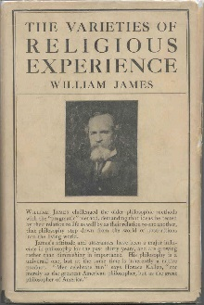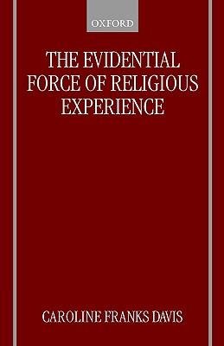**Component 2: Philosophy of Religion**

**Theme 3: Religious experience**

**Evaluation**

**Issues for analysis and evaluation will be drawn from any aspect of the content above, such as:**

• The **impact** of religious experiences upon religious belief and practice.

• Whether different types of religious experience can be accepted as **equally valid** in communicating religious teachings and beliefs.

  
• The **adequacy** of James’ four characteristics in defining mystical experience.

• The **adequacy** of Otto’s definition of ‘numinous’ *-‘mysterium, tremendum et fascinans’*

• The extent to which the challenges to religious experience are **valid**.

• The **persuasiveness** of Franks-Davis’s different challenges.

**Challenges to religious experience**

* **Problems:** It is difficult to prove that religious experiences are genuine:
* It has been claimed that **an experience on its own, cannot provide knowledge that its object `exists** i.e. ‘God’
* There are **no previous confirmed experiences of the object (God) on which to rely on**. This is difficult as obviously God is not a physical object. Some theologians believe that there cannot be any tests to confirm Gods existence
* **If the individual experiences God for the first time, how can they know that it is God?** There do not appear to be any properties of God that we are sure of and can recognise. It may be a case of mistaken identity
* **What the believer may see as an experience of God may be seen as something quite different by a non-believer or even by another believer**. No single religious experience can be replicated exactly, unlike a scientific experience. Personal (subjective) factors are involved so interpretation will inevitably vary.
* It is usually individuals rather than groups that undergo these experiences. As a result, we often have **only one person’s testi**mony as to what happened. For example, St Bernadette testified that the Virgin Mary had spoken to her; others who witnessed the ‘experience’ only saw her talking to an unseen ‘someone’.
* The **experiences are subjective rather than objective**, and therefore not open to testing and cannot be empirically verified or falsified. The experience is therefore open to interpretation.
* Religious experience is very like emotion – it is a personal response. This means that **any form of empirical testing is useless.**
* **It would appear that those who encounter these experiences portray the ‘being’ revealed to them quite differently**. In some cases, it is clearly the God of their respective faith. For example, stigmata are linked to Jesus, whereas Muhammad experienced the message of Allah. In other cases, it would appear to be a deity quite distinct from the God of formal or organised religion. For some, it is simply the force of nature.
* Is there evidence that **the individual or group may be under the influence of alcohol or drugs**? In many cases, drugs or alcohol can produce very similar effects to a religious experience. In *The Varieties of Religious Experience* (1902), William James refers to experiments using nitrous oxide and anaesthetics. He suggests that, when mixed sufficiently with air, these substances ‘stimulate the mystical consciousness in an extraordinary degree’.
* Is it possible that the religious experience is caused by a psychopathological medical condition? For example, the individual could be delusional or in the case of a corporate experience it could be the result of mass hysteria. **Richard Dawkins** in ‘The God Delusion’ claimed that there is no such thing as a religious experience – they were just expressions of a person’s psychological needs: *‘The argument from personal experience is the one that is the most convincing to those who claim to have had one. But it is the least convincing to anyone else, especially anyone knowledgeable about psychology…. If we are gullible, we don’t recognize hallucinations or lucid dreaming for what it is and we claim to have seen or heard a ghost; or an angel; or God…such visions and manifestations are certainly not good grounds for believing that ghosts or angels, gods or virgins are actually there.’***Richard Dawkins** claimed that testimonies of religious experiences are simply the manifestation of mental or psychological needs. Religious experiences are an illusion created by the mind to enable people to cope with their fear of the unknown:  
  *‘If you’ve had such an experience, you may find yourself firmly believing that it was real. But don’t expect the rest of us to take your word for it, especially if we have the slightest familiarity with the brain and its powerful workings.’*

MCj04346630000[1]**Positives:** When validating the experience as genuine, the following issues need to be considered

* Many argue that an experience of God is **so overwhelming that it is self authenticating** in itself
* **The experience does not have to involve a *direct* experience of God**. Rather it could be *inferential* such as an overwhelming feeling that the universe is directly dependent on something for its existence
* **Ultimately the truth of a religious experience comes through personal experience**. If the experience is interpreted in a religious sense it is genuine for the individual
* **Richard Swinburne** argued that if it seems to a person that they see something/someone, then it is usually the case that they have indeed seen something/someone (**the Principle of Credulity).**
* Swinburne argued that unless you have reliable reasons to doubt what a person says they have experienced, then what is said should be accepted as true **(the Principle of Testimony)**. Therefore, can what the person/people say be accepted as true?

The Principle of **Ockham’s razor** could also apply.

*Explain what this is and apply the argument to that of religious experience*

**Alternative explanations for experiences claimed as religious**

**The physiological challenge**

Could religious experience be the result of **electrical activity in the brain**?

But – even if such experiences are accompanied by electrical activity this does not explain their origin.

Could religious experience be the result of early brain tumour or epileptic fits (there is some evidence that epileptics are more prone to religious experiences).

**Temporal Lobe Epilepsy** – could cause an experience similar to those described by mystics

But what of those who have religious experience without either of these conditions?

**The Theological Challenge**

Mystics often speak of unity with the divine. From a theistic viewpoint, humanity and divinity are not to be equated.

BUT – could this unity be one of closeness rather than substance?

Why do some people have religious experience whilst others do not?

But – does respect for human freedom mean that God cannot force a religious experience on a person unwilling to receive it? Do all people have religious experience in the sense of some awareness of the reality of God?

**The Philosophical challenge**

Kant held that human beings have only five sense through which they apprehend the phenomenal world. Since God is not a part of the phenomenal world, we cannot have any knowledge of God.

But – could we not possess an altogether different sense for the non-phenomenal reality of God? (William Alston)

**The internal/external split**

The gap here is between reality and appearance. It may appear to a person that God is present in their experience, but how do we know that God is really present? Experiencing something does not necessarily mean the object exists e.g. hallucinations.

The atheist philosopher **A.J.Ayer** concluded that:

‘The mystic does not give us any information about the external world, he merely gives us indirect information about the conditions of his own mind.’

**Bertrand Russell** claimed that:

‘From a scientific point of view we can make not distinction between the man who eats little and sees heaven, and the man who drinks much and sees snakes.’

But – it is often claimed that such experiences are self-authenticating – the experiencer simply knows it is God. But does feeling that something is certain mean that it is?

**Richard Swinburne** attempts to bridge the reality/appearance gap by putting forward two principles:

**The Principle of Credulity** - this is a principle of rationality that (in the absence of special considerations) if it seems to person that X is present, then probably X is present. What one seems to perceive is probably so.

But – prior probability i.e. if a person thinks the probability of God is improbable then they are very likely to be sceptical about such experiences. Swinburne claims to have already established the probability of God’s existence through his cumulative argument for the existence of God. However, if this is not accepted then prior probability remains very much a subjective matter.

**Flew** – Ten deeply flawed arguments do not make a good one!

**William Alston** – prior assumptions play a part in the way we interpret something but that still means that something presents itself to our experience. If one already believes in God it is reasonable to accept that religious experiences are from God.

**Vicious Circle Challenge**

This idea holds that religious experience depends on the prior assumptions of those involved. So, Catholics will see Mary and Hindus are likely to experience Kali or Ganesh. This implies that instead of religious experience being a BASIS for faith, they are more likely to be generataed by existing faith commitments. They therefore have ‘no epistemological role’ – they do not underwrite faith. But, some mystics have experiences which challenge their existing frameworks of faith.

**Conflicting Claims Challenge**

This argues that if Christian religious experiences are used to support the truth of Christianity then Muslim experiences should equally be used to support the truth of Islam and and so on. The truth claims of one faith thus ‘cancel out’ the truth claims of the other. See Hume’s challenges to Miracles

But, some scholars such as John Hick, Keith Ward and Caroline Franks Davis claim that the same transcendent reality is being experienced in different ways. But, is there such a thing as a pure experience separate from its interpretation? Without description how do we know that the experiences are the same?

**The Logical Positivists**

1. **Use your knowledge of the Verification Principle – why would the Vienna Circle reject claims to have had a religious experience as meaningless.**
2. **Why would Flew’s Falsification Principle challenge claims to have had religious experience?**

**The Psychological Challenge**

Some psychologists hold that religious experiences can be explained by psychological factors. For instance:

**St Paul’s** experience on the Damascus road could have been due to an epileptic fit or may have arisen from subconscious guilt (stoning of St Stephen)

Perhaps they are psychological solutions to an emotional crisis e.g. a solution to the anxiety of meaningless (Sartre), the despair of economic and political exploitation (Marx) , the need for a parent substitute (Freud).

Could religious experience be explained in terms of voices from an unconscious part of ourselves?

**Jung** – Cole 101-102

But, some scholars have argued that this could be God working through the unconscious mind.

Could they be an inner disturbance projected onto the outside world in much the same say as a person may speak of spiders as ‘disgusting’?

But to say that some religious experiences can be explained psychologically odes not mean that all religious experiences can be so explained, neither does the fact that psychological factors are involved in religious experience mean that they are to be wholly understood in psychological terms. Presumably God would communicate through the diverse factors of human psychology/

**The anti – realist challenge**

This claims that there are no direct experiences of God – instead religious experiences are the way the world is seen by a religious believer. One ‘learns to find God in all things’ and this learning process depends on your framework.

But, is the whole anti-realist understanding credible

1. **Create a mind map of all the challenges facing religious experienceChallenges to the alternative explanations**
2. **The effect on the individual**

It is generally agreed that such an overwhelming experience is **life changing for the individual in a positive sense**. This could involve leading the individual to faith, a change in behaviour / actions etc 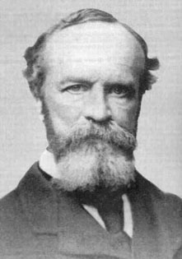

To reinforce this, **William James** believes that the result of a mystical experience, for example, will be reverence, a joyful desire to belong to God, a renewed approach to life.

***‘The results of a mystical experience are the only reliable basis for judging whether it is a genuine experience of the divine’ (James)***

**Outline two examples of the ‘life changing’ nature of religious experiences:**

**Use the internet / your notes for this!**

notes 3Examples you can choose include:

* St Paul
* Nicky Cruz
* St Teresa of Avila
* John Wesley
* Find your own examples (if you want)!

**Example 1:**

**Example 2:**

1. **St Teresa of Avila’s test**

**Find out what the details are of St Teresa of Avila’s test of a religious experience**

j0310392[1]

1. **The Catholic Churches procedure**

The Catholic Church evaluates all claims of visions and private revelations very carefully. The process by which the Catholic Church assesses such claims involves a number of elements:

Use the website below to explain what the Church’ criteria is for assessing such religious experiences: <http://en.wikipedia.org/wiki/Marian_apparitions>

1. 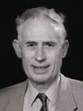**Swinburne’s Principle of Credulity & Testimony**

Use internet research and/or previous notes/reading, carefully explain what Swinburne proposes, making sure you apply the argument to religious experience:

**5. Corporate Experiences e.g. Toronto Blessing**

Use the internet, this booklet or your notes to find an example of a famous ‘corporate’ religious experience. Briefly outline this example and explain how this might challenge the alternative explanations of religious experience

Explanation:

**6. Alister Hardy’s Research centre:**

How does his research help verify/validate religious experiences? Explain- using reference to statistics

**Evaluate alternative explanations of experiences claimed as religious**

**Summary**

* Many people find religious experiences convincing – however they are significantly different to other human experiences because they are fundamentally not subjective to objective testing
* We cannot carry out a scientific experiment to determine whether they have, in fact, revealed God
* They cannot be scientifically proved
* Experiencing may also be unreliable because we can mistake what we experience.
* R.M. Hare describes the lunatic university lecturer who believes that all his colleagues want to kill him and interprets all their actions, however benign, as evidence for his belief. His interpretation of experience is clearly mistaken, but he continues to hold on to it.
* This is what **Hare** calls a **blik** – an unverifiable (cannot be proven true) and unfalsifiable (cannot be proven false) way of looking at the world.

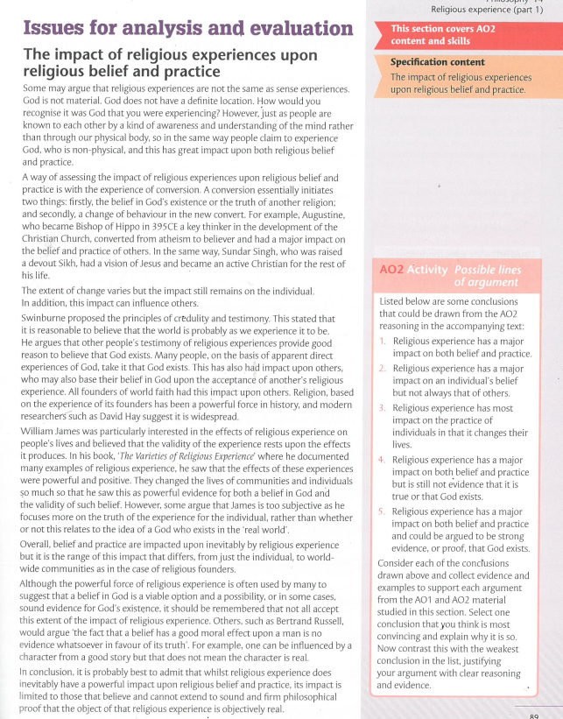

**‘Religious experiences have a significant impact on religious belief and practice.’ Evaluate this view.**

|  |  |  |
| --- | --- | --- |
| Argument  Significant impact | Counter argument  Not a significant impact | Evaluation |
| An individual’s experience can be life changing for them. Additionally, individual people’s religious experience within faiths can have an impact on others who already believe. | However, it will not have an impact on others. *‘If an experience happens to you personally it may change your perception of what is true. If it happens to someone else, it is less likely to change your perception, even if you accept that the experience has happened and that logically proves the existence of an outside force (God).*’ Peter Cole page 93 |  |
| **Swinburne** - Principle of Credulity and Principle of Testimony | Challenges to Swinburne – J.L. Mackie and Michael Martin |  |
| A posteriori evidence for God’s existence |  |  |
| Corporate religious experiences can consolidate faith of witnesses – Toronto Blessing |  |  |
|  |  |  |

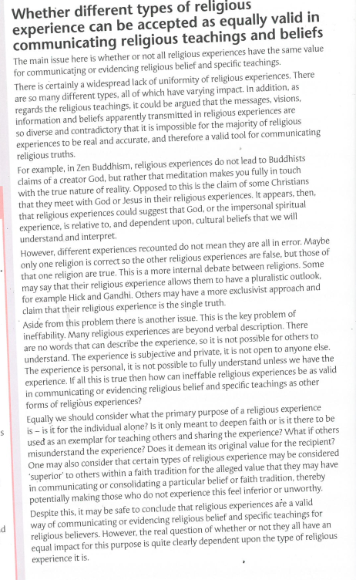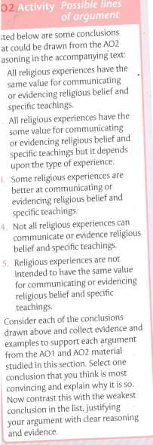

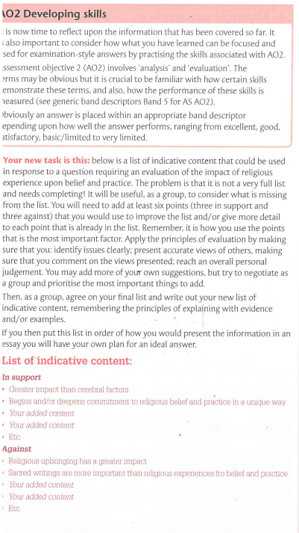

**‘All types of religious experience are equally valid.’ Evaluate this view**

|  |  |  |
| --- | --- | --- |
| Argument  All equally valid | Counter argument  Not all equally valid | Evaluation |
| All equally valid as all lead to greater commitment and change live  E.g. St Paul and John Wesley | Conflicting claims challenge – David Hume |  |
|  |  |  |
|  |  |  |
|  |  |  |
|  |  |  |

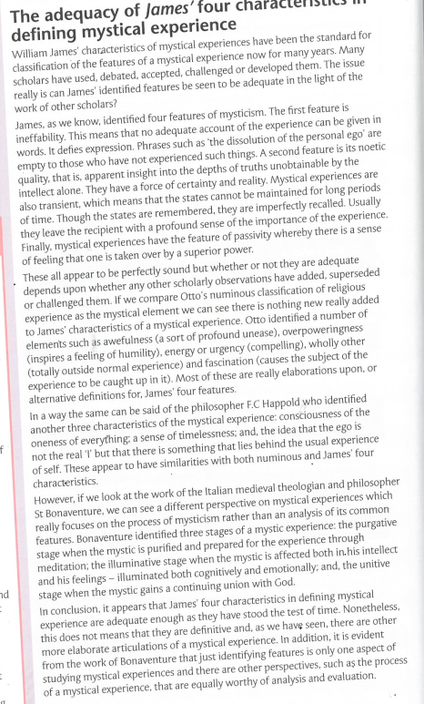

**‘James’ four characteristics adequately define mystical experiences’ Evaluate this view**

|  |  |  |
| --- | --- | --- |
| Argument  Adequate | Counter argument  Not adequate | Evaluation |
|  | Otto’s is better |  |
| Ineffability – found in many experiences e.g. St Teresa of Avila | Pahnke’s is better –  Alleged ineffability – although the experience is felt to be beyond words, most people who claim to have religious experiences make elaborate attempts to communicate the experience – metaphor etc. |  |
|  | Pahnke - Doesn’t focus on the positive changes in attitudes and behaviour that occur as a result of experiences – St Paul |  |
|  | Happold also identifies:  Consciousness of the oneness of everything  Sense of timelessness  The understanding that the ego is not the real ‘I’ – there is an immortal unchanging self that lies beyond ‘normal’ experience |  |
|  |  |  |

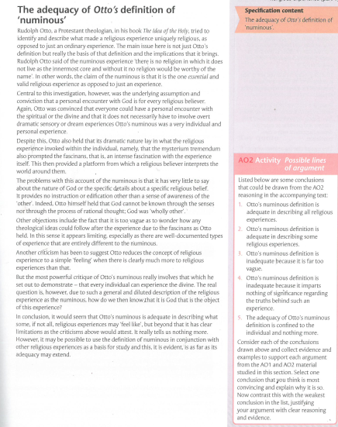

‘Otto’s definition of numinous experiences is adequate.’ Evaluate this view

|  |  |  |
| --- | --- | --- |
| Argument  Adequate | Counter argument  Not adequate | Evaluation |
|  | Doesn’t help us to understand anything about God |  |
|  | Too vague |  |
|  | Other scholars are more useful |  |
|  | Limits religious experience |  |
|  |  |  |

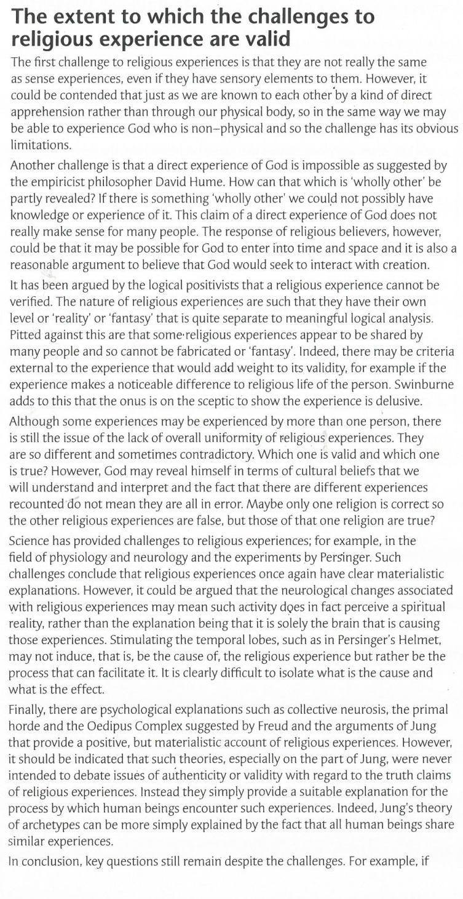

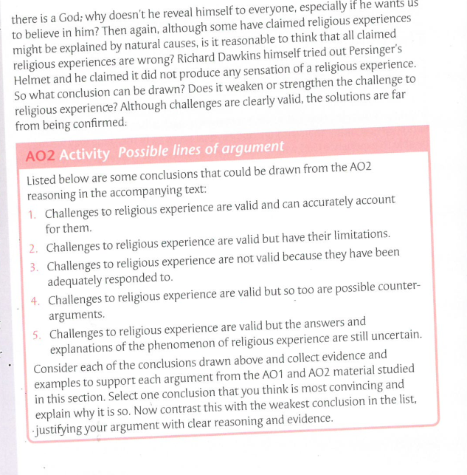

‘The challenges to religious experience are valid.’ Evaluate this view

|  |  |  |
| --- | --- | --- |
| Argument  Valid | Counter argument  Not valid | Evaluation |
| Not empirical – philosophical challenges |  |  |
| Can’t be verified |  |  |
| Psychological challenges |  |  |
|  |  |  |
|  |  |  |

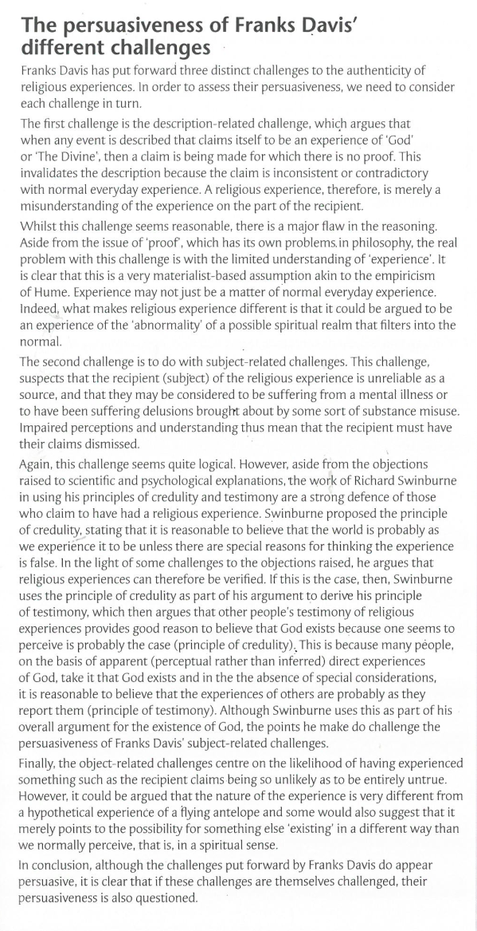

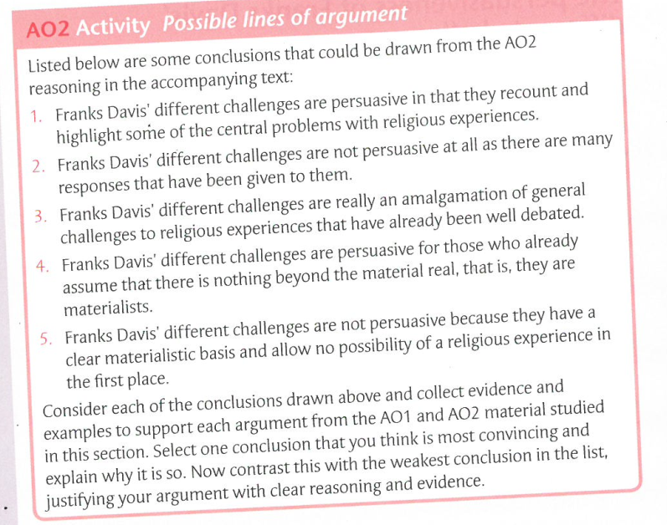

**‘Caroline Franks Davies’ challenges are persuasive.’ Evaluate this view**

|  |  |  |
| --- | --- | --- |
| Argument  Persuasive | Counter argument  Not persuasive | Evaluation |
| First challenge is persuasive |  |  |
| Second challenge is persuasive |  |  |
| Third challenge is persuasive |  |  |
|  |  |  |
|  |  |  |

